Project: Diamond Prices

# Step 1: Understanding the Model

*Answer the following questions:*

1. According to the model, if a diamond is 1 carat heavier than another with the same cut, how much more should I expect to pay? Why?

* *If the weight of the diamond (carat) is heavier by 1, I would expected to pay 8,413$ more for it. This is in accordance with regression and coefficient value of 8,413$ which means that if we decide to bought 1 carat heavier diamond than another the price will go up for that amount.*

1. If you were interested in a 1.5 carat diamond with a **Very Good** cut (represented by a 3 in the model) and a **VS2** clarity rating (represented by a 5 in the model), how much would the model predict you should pay for it?

* ***According to the regression formula I would have to pay 10,094.8$ for such a diamond. The formula in that case would look like this:***

***Price= -5269 + 8413 x 1.5 + 158.1 x 3 + 454 x 5***

# Step 2: Visualize the Data

Make sure to plot and include the visualizations in this report. For example, you can create graphs in Excel and copy and paste the graphs into this Word document.

1. Plot 1 - Plot the data for the diamonds in the database, with carat on the x-axis and price on the y-axis.

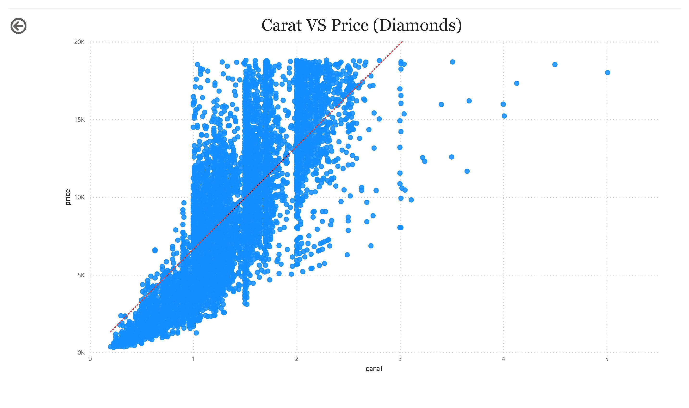

1. Plot 2 - Plot the data for the diamonds for which you are predicting prices with carat on the x-axis and predicted price on the y-axis.
   * **Note**: You can also plot both sets of data on the same chart in different colors.

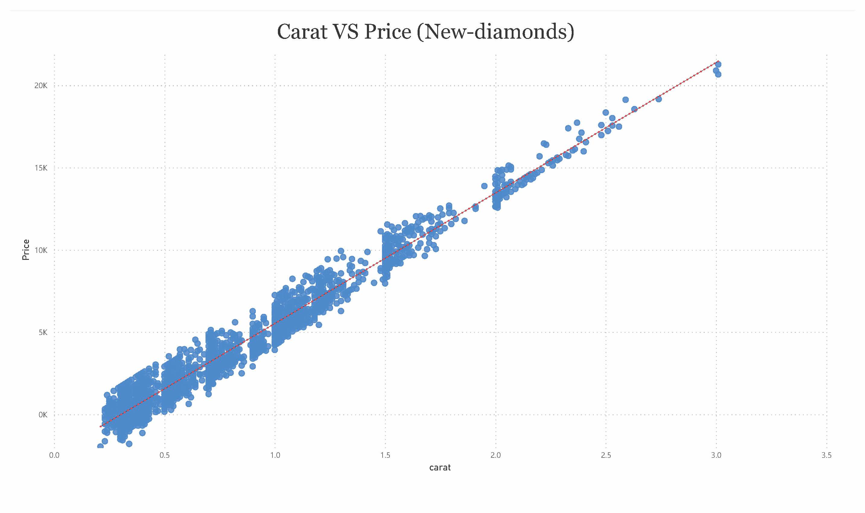

1. What strikes you about this comparison? After seeing this plot, do you feel confident in the model’s ability to predict prices?

* *We can see that two scatter charts showing that there is a relationship in Price and Carat. First graph related to Diamonds table showing good relationship but not the best like the second graph (New-diamonds). The reason for this could be the less population data (50,000 versus 3,000). Anyway we can conclude that there is a good relationship for building predicted prices.*

# Step 3: Make a Recommendation

*Answer the following questions:*

1. What price do you recommend the jewelry company to bid? Please explain how you arrived at that number.

* After I analyzed the relationship and done calculations, I would recommend 8,213,465.93$ for a bid. At first I have conducted regression formula to find a predicted price for each diamond. After it I summed up prices for all 3,000 diamonds and multiply it by 0.70, because the margin is 30%. After that I came up with a value of 8,213,465.93$.